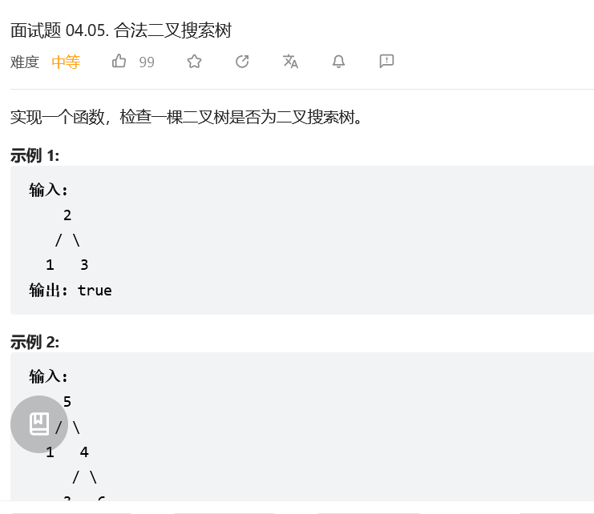
方法一：前序遍历
class Solution:
def isValidBST(self, root: Optional[TreeNode], left=-inf, right=inf) -> bool:
if root is None:
return True
x = root.val
return left < x < right and \
self.isValidBST(root.left, left, x) and \
self.isValidBST(root.right, x, right)

方法二：中序遍历

class Solution:
pre = -inf
def isValidBST(self, root: Optional[TreeNode]) -> bool:
if root is None:
return True
if not self.isValidBST(root.left) or root.val <= self.pre:
return False
self.pre = root.val
return self.isValidBST(root.right)

方法三：后序遍历

class Solution:
def isValidBST(self, root: Optional[TreeNode]) -> bool:
def dfs(node: Optional[TreeNode]) -> Tuple:
if node is None:
return inf, -inf
l_min, l_max = dfs(node.left)
r_min, r_max = dfs(node.right)
x = node.val
# 也可以在递归完左子树之后立刻判断，如果不是二叉搜索树，就不用递归右子树了
if x <= l_max or x >= r_min:
return -inf, inf
return min(l_min, x), max(r_max, x)
return dfs(root)[1] != inf



